Bug Inserted Output:

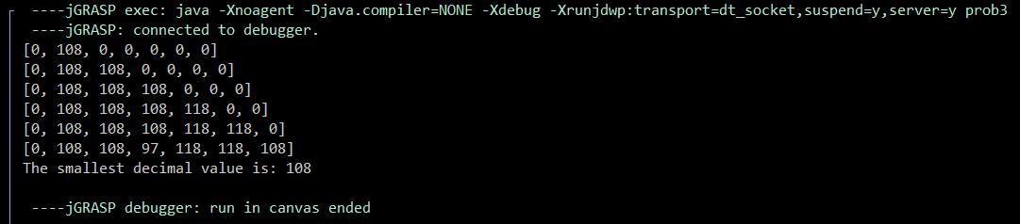

Some string inputs will not give the correct minimum value. For example, the above snippet shows the output of the string input: lvvva. The correct minimum value for this input string is 97, but the program returns 108. This runtime error occurs because the size variable controls which heap indexes get compared and the incorrect index is sometimes passed to get the wrong values to compare. Consider the following code sequence to see how the bug alters the output of the program.

Code sequence:

Heap {0, 108, 118, 118, 118, 97}

size = 6

parent = 6 / 2 = 3

heap {0, 108, 118, 97, 118, 118} since heap[6] < heap[3], swap the two

size = size – 2 = 4

parent = 4 / 2 = 2

heap {0, 108, 118, 97, 118, 118} since heap[4] !< heap[2], do not swap

Here is where the algorithm breaks because the wrong index is being used to check if a pair of indexes need to swap. The correct index should have been heap[3] < heap[1]. Instead, the parent variable should be removed and only the size variable should control all the index references as can be seen in the program for problem 3.

Bug Inserted Code:

